Title: Climate Stress Modeling on West Texas Abandonment
Author: Dustin Smith

Abstract:
Crop abandonment in the Northern High Plains and Northern Low Plains of West Texas represents an extreme agricultural risk, with regional historical abandonment averaging 21.62% compared to the national crop average of between 1 and 3%. This study evaluates the effectiveness of disaggregating seasonal climate stressors, GDD, and GDD departure calculations across three distinct developmental growing stages (First Flower, Last Flower, and Last Boll) to predict regional cotton abandonment. Utilizing annual crop and climate data from eight primary cotton-producing West Texas counties from 1968 to 2025, models were evaluated using a 42-fold sliding-window cross-validation. Regularized Quasi-Binomial Generalized Linear Models and non-linear Random Forest were tested against an aggregated baseline. While the full-season baseline model achieved the lowest loss metrics (RMSE 0.20–0.241), paired Wilcoxon Signed-Rank tests indicated no statistically significant predictive loss when utilizing disaggregated seasonal or GDD models. Notably, LASSO variable selection highlighted that County fixed effects strongly overpowered individual climate variables, and early-season climate stressors maintained high predictive utility. These findings demonstrate that early-season climate metrics can effectively substitute full-season aggregates for early-season risk assessment, though local geographic, financial, and management factors likely play a larger role in regional abandonment.

Introduction:
Crop abandonment is the act of abandoning a planted crop midseason. That is, a farmer actively chooses to abandon, destroy, or replant an already planted crop without harvesting. This can be due to many reasons, including a failed crop, a severely damaged crop (hail-damaged, as an example), extreme drought, or disease, etc. While this act can have devastating consequences for farmers, the food supply, and insurance companies, it is quite rare among US farmers. In fact, the national abandonment rate for all crops across the US averages between 1 and 3 percent. This, however, is untrue for a specific region for Cotton farmers. The agricultural districts in the Northern High Plains and Northern Low Plains in West Texas regularly see abnormally high abandonment rates. This region averages abandonment rates of 21.62% and has seen rates as high as 92.14% of all planted cotton. (Occurring in Terry County in 2022).
This particular region is also subject to extreme weather stressors such as extreme temperature swings, excessive heat exceeding 102 degrees, and extreme droughts. It is also common in related literature to assess climate in calculated values such as Growing Degree Days, or to split the climate data into seasonal growing stages. As such, this study aims to compare commonly used climate stressors and seasonal splits to assess cotton abandonment, to determine the effectiveness of these stressors and splits on modeling and predicting abandonment in this region.
The Statistical software R will be used with extensive libraries including GGPlot2, glmnet, ranger, and betareg for modeling.
Objective:
The objective of this study is to assess climate stressors and common agricultural measures on modeling and predictability of abandonment in West Texas regional cotton, while assessing the effectiveness of seasonal growing stages on model reliability.
Related Research Questions:
- Heat-related stress indicators, including cumulative GDD and extreme heat days, have increased over time, while moisture availability has dropped. Cotton abandonment rates are expected to be higher in years characterized by high heat and low moisture availability.

H1: There is a temporal change in temperature and precipitation in the west Texas region.
H₀: There is no change in TMAX or PRCP over time.
H_{A1}: There is a positive (+) change in TMAX
H_{A2}: There is a negative (-) change in PRCP

H2: The interaction between PRCP and TMAX is significant for predicting abandonment
H₀: β_{(PRCP * TMAX)} = 0
H_{A}: β_{(PRCP * TMAX)} > 0

- Stage-specific (seasonal cotton development) climate variables will improve predictive accuracy compared with whole-season aggregate variables, because cotton abandonment is influenced not only by the magnitude of climate stress but also by its timing within the crop development cycle.

H3: The median RMSE of a model using disaggregated climate data is significantly lower than that of a model using only total aggregated data.
H₀: $\tilde{μ}$_{RMSE_total} $- \tilde{μ}$_{RMSE_seasonal} = 0
H_{A}: $\tilde{μ}$_{RMSE_total} $- \tilde{μ}$_{RMSE_seasonal} > 0

- GDD variables will be significantly associated with cotton abandonment, and have differing effects at different seasons. Models that incorporate departures from averaged GDD along critical seasonal growth cycles for cotton alongside climate stressors will better explain abandonment risk as opposed to climate data.
H4: The median RMSE of a model using GDD has a significantly lower RMSE of a model that only incorporates general climate stressors.
H₀: $\tilde{μ}$_{RMSE_total} $- \tilde{μ}$_{RMSE_GDD} = 0
H_{A}: $\tilde{μ}$_{RMSE_total} $- \tilde{μ}$_{RMSE_GDD} > 0

- While cotton production benefits from some climate stress, it heavily suffers when stressors become too extreme. The relationship between environmental stressors (particularly extreme heat and season 3 GDD departures), and regional cotton abandonment is largely non-linear. Flexible non-linear models will produce statistically lower loss and improved predictability than strictly linear fractional logit models.

H5: Non-linear methods will produce a significantly lower median RMSE than linear-based GLMs.
H₀: $\tilde{μ}$_{baseline} $- \tilde{μ}$_{non-linear} = 0
H_{A}: $\tilde{μ}$_{baseline} $- \tilde{μ}$_{non-linear} > 0

* Note: Here $\tilde{μ}$ indicates a median value, not a mean value. The specific test used is a paired Wilcoxon-Signed Ranked Test, which takes median values on non-normal data. While the cross-validated sample size is likely enough for the central limit theorem to apply, the sample size is small enough that using a non-parametric method due to the extreme skewness of the target is more reliable.

The Data
The original data was sourced directly from NASS and NOAA. The Cotton data (NASS) originally contained 21 variables with 7,723 observations from 40 different counties, whereas the Climate data (NOAA) contained 30 variables with 254,370 combined observations. The original data was pulled from 40 counties in the Texas High Plains (Both Northern – Region 11, and Southern – Region 21) in the years 1968 to 2025. This data was reduced to two subsets consisting of 36 variables and 441 observations (reduced to 428 when removing missing observations), and a second data set containing 2 variables, 515 observations, and a nested variable of 184 observations for each county and year.
The final variables were chosen based on current literature, utility for the designated objective and hypotheses, and completeness. The choice of dates (1968 to 2025), was made for consistent climate coverage in regions and to provide ample historical abandonment rates for baseline comparisons. The original 40 counties were reduced to 8 counties. These are Hale, Crosby, Lamb, Gaines, Lubbock, Randall, Dawson, and Terry. As the study is interested in assessing abandonment risks for insurance risk aversion, the counties with the highest cotton production were of high interest. A single climate station was chosen per county (containing > 95% coverage) to assess holistic climate data. The variables chosen are listed below:
- Year – Annual data from 1968 to 2025
- District – Discrete data of only ‘11’ and ‘21’ for agricultural districts. (Categorical)
- County – (Categorical)
- Total Harvested – Used for Abandonment calculations
- Total Planted – Used for Abandonment calculations
- Irrigated Harvested – Used for Abandonment calculations
- Irrigated Planted – Used for Abandonment calculations
- Non-Irrigated Harvested – Used for Abandonment calculations
- Non-Irrigated Planted – Used for Abandonment calculations
- Total Abandonment – Percentages of overall regional abandonment
- Irrigated Abandonment – Percentage of abandonment for Irrigated regions
- Non-Irrigated Abandonment – Percentage of abandonment for dry-land regions.
- T-Max (S1, S2, S3, Total) – Averaged Maximum Temperatures
- T-Min (S1, S2, S3, Total) – Averaged Minimum Temperatures
- T-PRCP (S1, S2, S3, Total) – Total Precipitation
- Hail (S1, S2, S3, Total) – Count of days with hail
- Extreme Heat Count (S1, S2, S3, Total) – Count of days with heat exceeding 102 Degrees (39 Celsius)
- GDD (S1, S2, S3, Total) – Growing Degree Days max(0,Calculated with Average(TMAX, TMIN) - 60)
- DailyGDD – Cumulative GDD per region and year
- GDD Departure – Daily GDD departure from the overall average GDD.

While the climate data was near complete, there is still extensive missing data. For example, variables PRCP, SNOW, TW05 (Hail) contained missing or NA values when the weather was not observed. This can occur for true missing data, but usually appears missing because there was simply no precipitation on those days. These were then coerced to zero for yearly summing. Irrigated and Non-Irrigated Abandonment also consisted of extensive missing data. Due to the region being labeled “Dry-Land”, the collection of Irrigated and Non-Irrigated acres has not been collected in all counties in recent years.
To calculate the seasonal splits, the data were split into four subgroups. First Flower S1 (May and June), Last Flower S2 (July and August), Last Boll S3 (September and October), and total (all 6 months). Averages were calculated for TMAX and TMIN, while total sums of PRCP, Hail (WT05), and the total number of days beyond 102 degrees Fahrenheit were found. GDD (Growing Degree Days) was also calculated using the sum of the averaged TMAX and TMIN beyond 60 degrees. This creates a useful measure of the amount of heat a plant receives that is conducive for cotton flowering. Abandonment rate was also calculated from the ratio of the difference in Total Planted and Harvested cotton to Total Planted Cotton.
An additional dataset was created to provide more information on GDD. As opposed to the above GDD, which is a total GDD by season, it may prove useful to have a cumulative or running total of the GDD throughout the season. Unfortunately, the small amounts of missing data present posed a large problem when working with Accumulated GDD (defined as DailyGDD). In the climate data, averaging the TMAX and TMIN masked the small number of missing data it contained. As the ratio of missing data is 1110 to 490,610 observations, or about .226% of the data, the missing data was deemed a non-issue. However, when assessing DailyGDD, the missing data compounded, producing 78,000 additional missing values (16% of the data). As this was no longer insignificant, the missing data was addressed by inputting regional means for each missing slot. Leaving the values at zero could dramatically undercut the total GDD and provide misleading variance, while averaging from only Randall could cause issues if there is continuous missing data for Randall. Averaging for regional data was deemed most appropriate.
With this correction in place, the DailyGDD was constructed as a Nested dataset for each County and Year. It contains the running totals of the 184 days of cotton growth. Lastly, a few fields were found to have nearly complete missing data and were removed for analysis. This accounted for around 11 total observations in the data set.
The overall DailyGDD for the 184 days of the growing season was found, and the daily GDD departure measure was taken as the difference in individual DailyGDD against the baseline Average GDD.
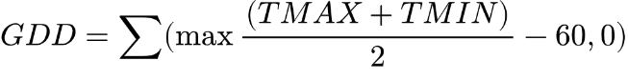
Equation 1 and 2:

Exploratory Data Analysis:
The average abandonment for the observed data is 21.62%, and has an overall standard deviation is also quite high at 21.09%. While it is rare for the abandonment in this region to reach 0%, only occurring in 0.457% of the observations, the upper bound of the cotton abandonment is extremely high, reaching 92.14% in Terry County in 2022.
The climate data is highly skewed, volatile, and increasing over time. Both linear and GAM smoothing curves show a sharp increase in abandonment, which reaffirms the current literature. The majority of the counties have a common center of around 22%, while some counties such as Randall have higher abandonment than others. There are a few outlying extremes. However, these extremes are real and will cause a profound effect on insurance and local growers and should not be removed.
County | Average | Standard Deviation
Crosby | 0.15 | 0.19
Dawson | 0.22 | 0.26
Gaines | 0.2 | 0.19
Hale | 0.2 | 0.2
Lamb | 0.24 | 0.22
Lubbock | 0.17 | 0.19
Randall | 0.33 | 0.22
Terry | 0.22 | 0.21
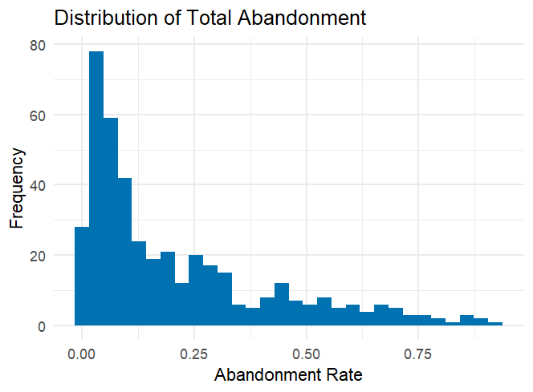
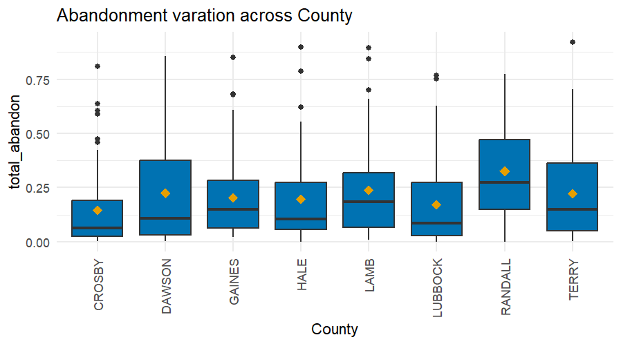
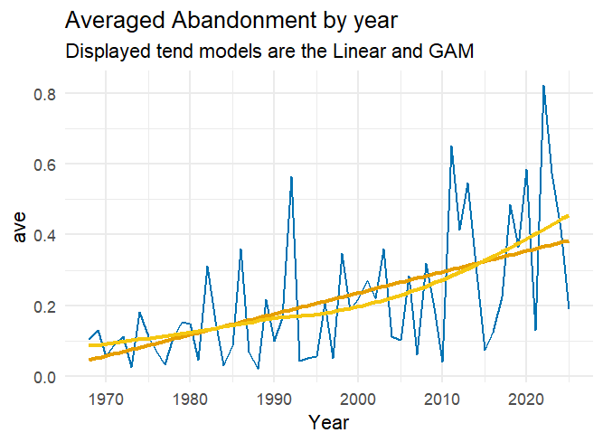

The exploratory analysis does indicate that there are differences in the trends of overall temperature measurements and their seasonal splits. In many instances, some seasonal splits show a steeper trend in abandonment over total abandonment, while other splits show a shallower trend. Similarly, we can see that Season 2 in most climate stresses exhibits equal or higher correlations to abandonment than the total stressors. What is more interesting, and likely more useful for modeling, is the lack of correlations in other seasons. Season 3, for example, shows few stressors that exhibit any correlation with abandonment. This may allow us to strip away the meaningless seasonal climate stressors and shift to focusing only on the seasons that primarily affect abandonment.
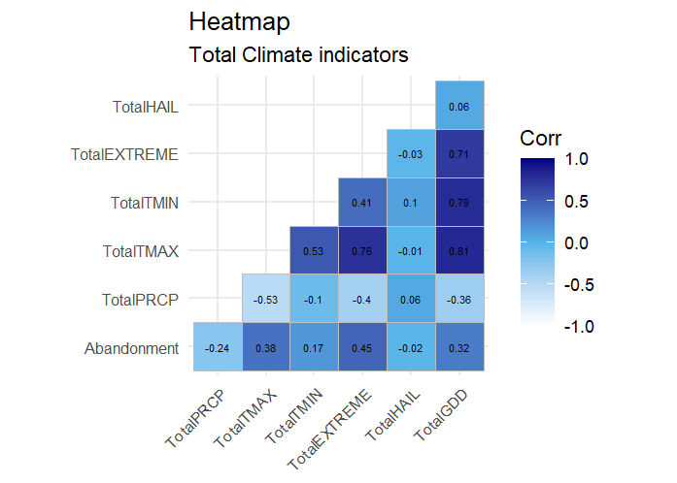 | 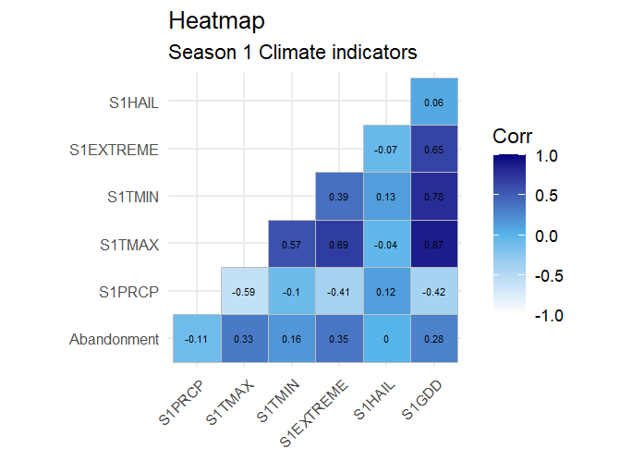
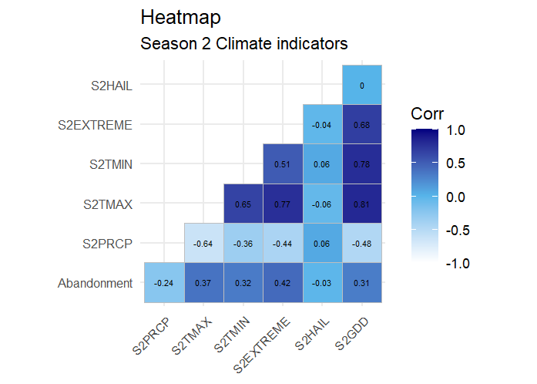 | 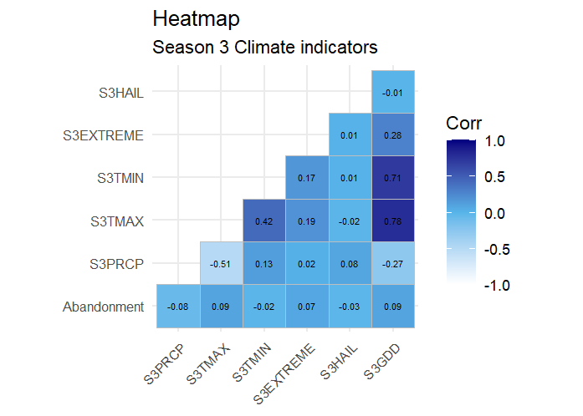

We can see that the variation in DailyGDD is quite profound. In the figure below, each county is plotted by year against the overall average DailyGDD. As expected in season 1, there is little variation, but as time progresses, the variation continues to increase. This may be an indicator as to why research shows that abandonment occurs primarily in season 2, and why we see stronger correlations in season 2. Also, when plotting individual explanatory variables against the target, non-linear effects become more apparent. In many situations, the data exhibit quadratic and even cubic trends. This further motivates the need to employ non-linear methods to account for the extreme changes the climate stressors cause.

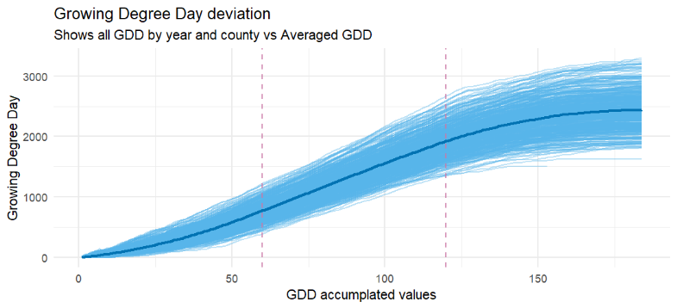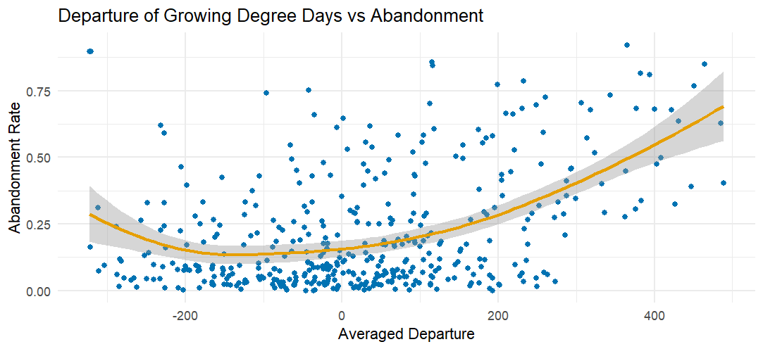
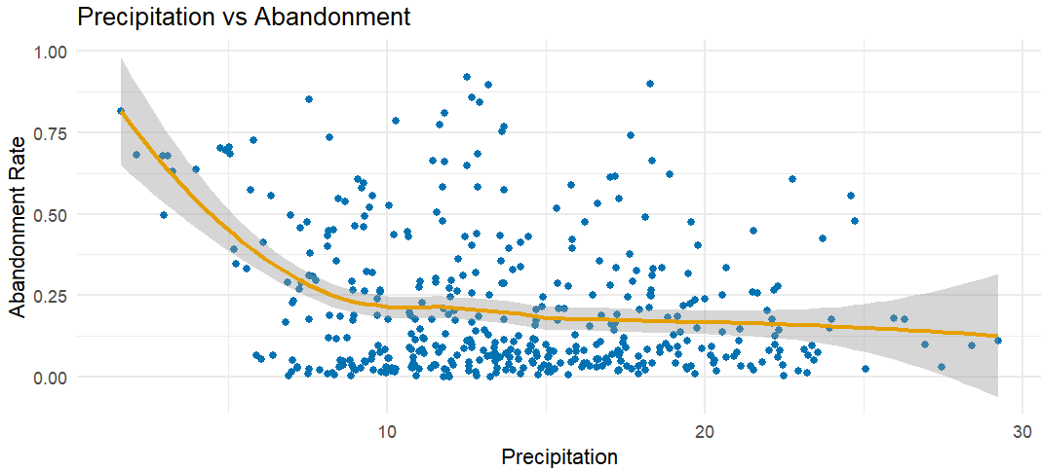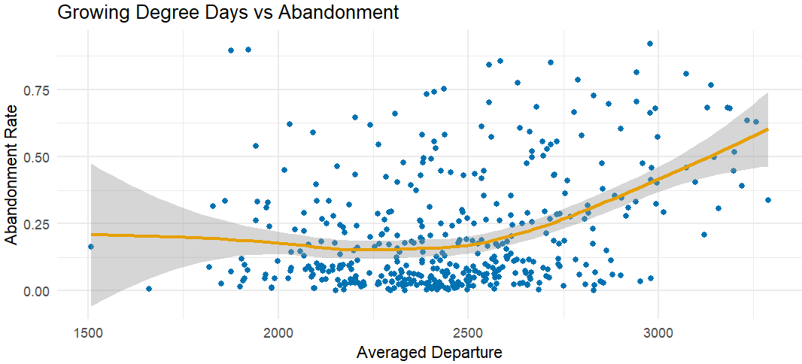
Overview or Methods:
Research Question | Hypothesis | Data | Methods
Heat-related stress indicators, including cumulative GDD and extreme heat days, have increased over time, while moisture availability has remained constant. Cotton abandonment rates are expected to be higher in years characterized by high heat and low moisture availability. | H1: There is a temporal change in temperature and precipitation in the west Texas region  H2: The interaction between PRCP and TMAX is significant for predicting abandonment | - Total_abandonment  - PRCP  - TMAX | - Mann-Kendall Statistics FDR alpha inflation control  - GLM quasi-binomial  - t-statistics
Stage-specific (seasonal cotton development) climate variables will improve predictive accuracy compared with whole-season aggregate variables, because cotton abandonment is influenced not only by the magnitude of climate stress but also by its timing within the crop development cycle. | H3: The RMSE of a model using disaggregated climate data is significantly lower than that of a model using only total aggregated data. | - Total_abandonment  - PRCP  - TMAX  - TMIN  - EXTREME  - Seasonal S1  - Seasonal S2  - Seasonal S3  - County | - Sliding Window Cross Validation  - Quasi-Binomial GLM  - RMSE  - WRMSE  - Wilcoxon Signed-Ranked Test
GDD variables will be significantly associated with cotton abandonment, and have differing effects at different seasons. Models that incorporate departures from averaged GDD along critical seasonal growth cycles for cotton alongside climate stressors will better explain abandonment risk as opposed to climate data. | H4: The RMSE of a model using GDD has a significantly lower RMSE of a model that only incorporates general climate stressors. | - Total_abandonment  - GDD  - S1 GDD  - S2 GDD  - S3 GDD  - S1 TMAX  - S2 TMAX  - S3 TMAX  - S1 TMIN  - S2 TMIN  - S3 TMIN  - County | - Sliding Window Cross Validation  - Quasi-Binomial GLM  - RMSE  - WRMSE  - Wilcoxon Signed-Ranked Test
While cotton production benefits from some climate stress, it heavily suffers when stressors become too extreme. The relationship between environmental stressors (particularly extreme heat and season 3 GDD departures), and regional cotton abandonment is largely non-linear. Flexible non-linear models will produce statistically lower loss and improved predictability than strictly linear fractional logit models. | H5: Non-linear methods will produce a significantly lower RMSE than linear-based GLMs | - Total_abandonment  - GDD Departure  - S1 GDD Departure  - S2 GDD Departure  - S3 GDD Departure  - S1 TMAX  - S2 TMAX  - S3 TMAX  - S1 TMIN  - S2 TMIN  - S3 TMIN  - County | - Sliding Window Cross Validation  - Random Forest  - RMSE  - WRMSE  - Wilcoxon Signed-Ranked Test

Method Reasoning and Explanation:
The target data (total abandonment) is continuous and bounded by 0 and 1. It includes fractional percentages and does not behave in a binomial or categorical manner. It is truly continuous, but bounded. The data is also autocorrelated with a temporal nature and exhibits spatial correlations between counties. However, the objective is not to produce forecasts, but to understand which climate splits and calculations are best suited for predicting abandonment. Or even if climate stress is useful for predicting abandonment.
Therefore, an appropriate method must be chosen to account for the continuously bounded data and, while not ignoring the temporal or spatial autocorrelation, does not use common time-series methods but instead uses methods useful for predictive modeling. Therefore, a series of methods were chosen to address the objectives and hypotheses. Due to its abundance in the literature and applicability to the current study, the Quasi-Binomial Generalized Linear Regression with Logit links was chosen as the base method. A sub-method, which is pure to the target data, would be a Beta Regression. This can be later explored in place of the GLM as the sub model. More details are provided below by research questions.

Equation 3: Logistic Regression

Research Question 1: Interaction Terms:
The first question assesses the usefulness of interaction PRCP and temperature terms. While it can be easily seen that precipitation (PRCP) has been decreasing and temperature (both minimum and maximum) has been increasing over time. The question of their actual interaction for modeling needs to be shown. Common literature does support that the presence of water is necessary for plant survivability in extreme temperatures. In fact, many plants such as cotton use evapotranspiration to cool themselves during hot summer days. Thus, ensuring that cotton has sufficient water can extend its life during extreme heat. In the past, farmers have regularly used supplemental watering (not true irrigation) to allow sufficient stress for cotton production, but to mitigate the effects of extreme heat. On the other hand, the aquifer levels are becoming low and extremely expensive to access. As a consequence, in recent years farmers in the West Texas region have nearly abandoned irrigation and have migrated to true ‘dry land’ cotton.
Because of this, it is not acceptable to assume that the interaction between water and cotton is useful for modeling abandonment, as farmers are actively moving away from supplemental watering entirely. This is the motivation for this question. Is the interaction between PRCP and temperature still useful?
To assess this, a few steps will be used. First, we must establish that the trend within each explanatory variable is indeed significant. The non-parametric Mann-Kendall test will be used to establish this. Due to the number of explanatory variables being assessed (24) there is danger of alpha inflation and finding non-meaningful significances. To adjust, the False Discovery Rate (FDR) will be employed to control for this alpha inflation. From here, assuming significance is found, a simple Quasi-Binomial GLM containing only precipitation, temperature, and their interaction will be constructed. Investigating the t-statistics can provide light on its usefulness for modeling.
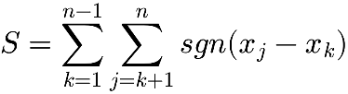
Equation 5: Mann Kendall Statistic

Research Questions 2, 3, and 4:
From here, we can begin assessing the usefulness of disaggregating the stressors, applying GDD, or divergent GDD for modeling abandonment compared to ordinary aggregated stressors. That is, we want to determine if splitting the data to differing seasonal splits or applying agricultural GDD values proves a lower overall Weighted RMSE value. To perform this, a few adjustments and careful data handling must be considered.
First, we must recognize that the data is inherently autocorrelated by year. To control for temporal autocorrelation careful Cross Validation must be established. Therefore, a the custom cross-validating sliding window was chosen. It allows the data to maintain some of the correlation, and then predicts the errors (loss) on a smaller future window. This will honor the data’s natural autocorrelation, while allowing predictive modeling to be used, as opposed to pure time-series methods.
The data was split into near-equal test sets spanning 10 years to predict upon the next year of data. This will allow nearly 10*8 = 80 observations, and 1*8 = 8 test data. Unfortunately, only allows for 5 to 6 separate folds. Therefore, the step size was fixed to 1 to allow the folds to ‘move’ up the data, and allow overlapping train observations between the folds. This increases the overall number of folds to 42. To avoid potential data leakage the test data was reduced to 1 year. This will ensure the test data does not overlap in folds, but may remove some statistical power on the resulting tests.
From here four different models were chosen. These will employ the Quasi-binomial General Logistic Regress described above. Those consist of Total using only aggregated total climate values and their interactions, a second Seasonal Model using Seasonal Stressor Splits instead of the aggregated totals, a GDD model using the GDD splits, and a GDD departure Model using the GDD Departure calculations.
With the data in place, regularization, cross-validation, loss calculations, and hypothesis testing can be used to directly address the provided hypotheses. As the Quasi-binomial regression is not a true MLE, but a Quasi Estimate, direct regularization cannot be used. However, the R library glmnet allows a common work around where the binomial distribution can be used with express weighting and variance control to allow the model to behave as a Quasi-Binomial and still operate under the MLE allowing for regularization with Elastic Nets. To allow this to occur the weighs must be explicitly used, here they are the total planted acreage per year and county. The explicit success/failure parameters of the binomial must also be explicitly defined. That is the Failure = 1 – train_fold$total_abandon and the Success = train_fold$total_abandon, where the ‘success’ value is the abandonment rate.
The Elastic Net was set to .3 allowing for a heavier weighting on Ridge then on LASSO to control for the multicollinearity present in the data. (This will be discussed further in the Assumptions Section Below).
For each fold the weighted and non-weighted RMSE was found. As the data is by nature decimal but continuous, the RMSE was deemed more appropriate as opposed to the typical Log-Loss for GLM models. Even though the Log-Loss handles categorical data excellently, here the data fits a RMSE or MSE loss better. Both RMSE and Weighted RMSE were calculated, as the GLMs must use weighting to correctly account for different sized acreage. However, the Random Forest does not explicitly use weighting. Therefore, to be as fair as possible for each model, all four loss functions (RMSE, WRMSE, Log-Loss, WLog-Loss) were calculated, but only RMSE and WRMSE were used in the final hypothesis test.
As we controlled for a common cross-validation for all models, a paired test can be performed to assess if any model preforms significantly different from the baseline Total model. However, recall that the target is highly non-normal, and the total folds is only 42 in length. This allows at best 42-1 = 41 degrees of freedom on a conventical t-test, and considering that square rooting values can cause non-normality it was deemed safest to use the non-parametric Paired Wilcoxon Signed-Rank test to evaluate the hypotheses. Here again testing multiple p-value can cause alpha inflation be an issue. However, the p-values now number at 4 not 24, so the Bonferroni correction is preferred here. Making the alpha cutoff .0125 instead of the usual .05.
Equation 6: Wilcoxon Signed-Rank Test

Finally, the Random Forest was chosen as the non-linear method for its ability to ignore collinear data, and handle non-linear complex changes in variables. GAMS were a very favorable option for the cubic-splines ability to handle complex changes in variables against abandonment. For example, TMAX has a distinctly negative cubic curve. Unfortunately, GAMs are very susceptible to collinearity and would require careful regularization to perform well against the regularized GLMs. Therefore, Random Forests were deemed a more suitable method.
Assumptions and Issues:
Here we will discuss the various assumptions and issues that arose during modeling and how each issue was controlled. The first valid issue to control is the possibility of a zero inflated data. However, when assessing the number of 0 abandonment, it was found that out of the 428 observations only two values were returned as zero. This combined with the mean abandonment of 21.62% indicates that zero inflation is not an issue for these data. However, if the beta regression is to be attempted the 0 values will break the beta regression, as it assumes the data is strictly bounded by 0 and 1. As only two values need adjusting, the usual method (defined by the betareg library) of adjusting all values is unnecessary. Instead, simply coercing the 0s to .0001 should suffice.
Another issue, is the possibility of special correlation within the counties. Counties were added to the model as Fixed Effect or dummy intercept values. This was deliberately chosen to control for the possible correlation between connected counties. Here the Counties are Fixed effects being set as dummy intercept values; however, when running the model, we will find that the global intercept will take overwhelming control of the model, so the global intercept was removed. The regularization (LASSO) was explicitly controlled to ignore the Counties, as we do not want a model where one County has been removed.
Luckly, the GLM requires very few assumptions to be used. One of those assumptions is that the data is independent, and not collinear. Unfortunately, these data exhibit massive multicollinearity, due to much of the data being disaggregated or calculated form other data. VIF calculations when including all variables can reach values ranging from 1.32 to 67.45 with an average VIF value is 12.38. This is beyond extreme. To control for this extreme multicollinearity, careful measures were taken. First, in no model were the total climate values and split or calculated values all included. The models either contained the totals (aggregated values) or the splits and calculate values. Another measure of added control was to allow the model to be computed as completely separate models. Instead of using nested models or likelihood ratios, paired testing was used to avoid possible multicollinearity of including too many connected variables. When incorporating these steps, we can see that within each model the VIF values go down to moderate with average values of 3.38 in totals only, 4.55 in seasonal data, 1.25 in GDD only models, and 8.08 in the GDD departure only model. While the GDD departure still exhibits extreme multicollinearity, the other models are within reasonable ranges.
In addition to the above method for controlling for multicollinearity, when preforming regularization, the choice of weighting heavier to the Ridge was made to help reduce the remaining multicollinearity.
Standardized deviance residual plots were produced for each model to assess their overall fit. For each model the residual plots exhibited acceptable random spread and equal variance. You will notice, however, that the variance tappers off when in the upper values of abandonment. As this is likely an issue of sparsity in the abandonment beyond .6, it is unlikely to be an artifact of a poor fit, and each model was deemed acceptable. The residual plots are below:
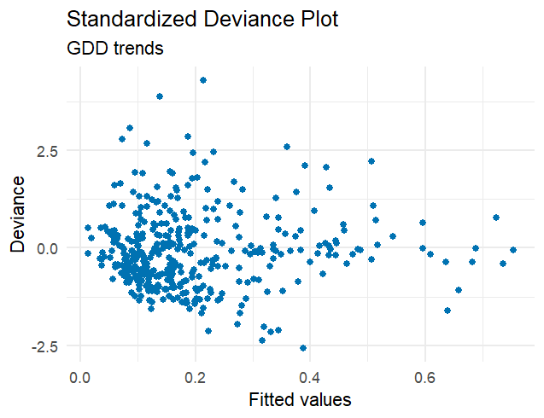
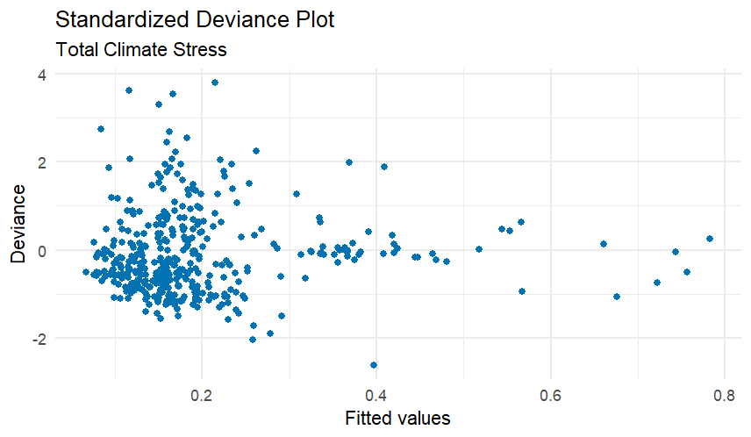
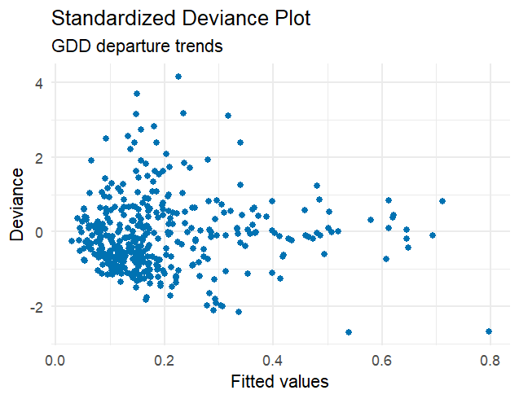
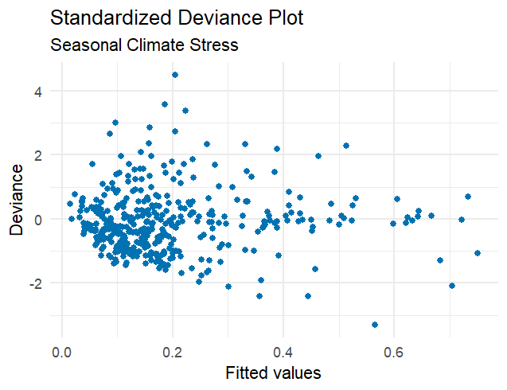

Results:
The table to below contains all of the Mann-Kendall Statistics used for H1, after being pushed through FDR for alpha inflation. Interestingly the majority of the statistics are significant. Only season 1 and 3 Precipitation, Season 2 and 3 Hail were not significant. This is quite reasonable as Hail and rain historically tend to be occur in small windows for the West Texas region. The significant Season 2 PRCP and Season 1 Hail likely indicates that those are the seasons where Hail and Rain are most likely to occur. Further, running PRCP, TMAX, and their interaction into the quasi-binomial GLM model produces significances in all terms. Including the interaction term with a p-value of 0.0000592. This provides a legitimate reason to include the interaction term in the later models.
Variable | Coefficient | Statistic | p-value
TotalTMAX | 0.440602 | 6.933 | 1.54 x 10⁻¹¹
TotalPRCP | 1.615464 | 4.010 | 7.17 x 10⁻⁵
Interaction | -0.018779 | -4.057 | 5.92 x 10⁻⁵

Variable | P.Value | Tau | Significant | Variable | P.Value | Tau | Significant
total_abandon | 0.00000 | 0.3 | Yes | S2GDD | 0.00000 | 0.236 | Yes
S1TMAX | 0.00036 | 0.12 | Yes | S3TMAX | 0.00000 | 0.194 | Yes
S1TMIN | 0.00000 | 0.224 | Yes | S3TMIN | 0.000001 | 0.161 | Yes
S1PRCP | 0.66586 | -0.015 | No | S3PRCP | 0.09958 | -0.055 | No
S1HAIL | 0.02873 | 0.085 | Yes | S3HAIL | 0.91318 | 0.004 | No
S1EXTREME | 0.00076 | 0.121 | Yes | S3EXTREME | 0.03384 | 0.086 | Yes
S1GDD | 0.00000 | 0.198 | Yes | S3GDD | 0.00000 | 0.22 | Yes
S2TMAX | 0.00000 | 0.202 | Yes | TotalTMAX | 0.00000 | 0.26 | Yes
S2TMIN | 0.00000 | 0.273 | Yes | TotalTMIN | 0.00000 | 0.264 | Yes
S2PRCP | 0.00516 | -0.095 | Yes | TotalPRCP | 0.01230 | -0.085 | Yes
S2HAIL | 0.19351 | 0.053 | No | TotalHAIL | 0.02260 | 0.088 | Yes
S2EXTREME | 0.000003 | 0.167 | Yes | TotalEXTREME | 0.00000 | 0.191 | Yes

Below we can find the results for the Cross Validated model comparisons. Interestingly, the Total aggregated model preformed best in nearly all of the Loss categories. It is likely that the aggregated data keeps some information from all of the other categories and provides the simplest model. All models exhibited similar RMSE values in the range of 0.20 to 0.241 with the GDD model preforming worst in RMSE and Seasonal preforming worst in the Log-Loss.
Based on these values, and the associated confidence intervals, we cannot conclude that any one model preforms significantly better or worse than another model, even though the Total model exhibits slightly better loss values, and reduces the log-loss values by nearly 0.20 points.
The Random Forest does, however significantly outperformed all GLM models. It is likely that the Random Forest handled the multicollinearity best, and is most adequate at handling complex non-linear natures.
Model | RMSE | WRMSE | Log Loss | WLog Loss | Wilcoxon P-Value | Confidence Interval
Total | 0.2216 | 0.2083 | 0.5533 | 0.5373 | … | …
Seasonal | 0.2379 | 0.2267 | 0.7848 | 0.7633 | .6224 | (0.192, 0.226)
GDD | 0.2404 | 0.2291 | 0.7059 | 0.7038 | .9653 | (0.207, 0.241)
GDD Departure | 0.2404 | 0.2294 | 0.7288 | 0.7038 | .3924 | (0.207, 0.240)
Random Forest. | 0.1605 | 0.1476 | 0.4922 | 0.4754 | 0.000 | (0.148, 0.173)

When allowing LASSO to take the majority preference at .9, we can see what variable are kept and dropped. Including the County Fixed effects, the factors kept are S3TMIN, S1HAIL, S1TMAX, S2PRCP, S3PRCP, S1Departure, S1EXTREME, S2EXTREME, S3EXTREME, as well as the interaction terms. Here it is clear that the Fixed Effect County overpowers the majority of the other variables. This may indicate that regional factors such as groundwater depletion, soil water retention, market values, or local farming practices may have a large effect then climate. Thereby the climate stressors maybe secondary to other regional factors.
Summary:
Based on the results, we can see that the split models do not produce significantly different Loss values as opposed to the aggregated model. However, there is still some value in using the seasonal data against the total aggregated data. While it is true that the total model preformed best, it is by no means significantly better than the seasonals split. Therefore, this study does not find a reason that one must use total aggregated climate stressors for abandonment predictions. In fact, in the pure LASSO, the majority of the remaining variables exist in the earlier seasons. That implies that if early abandonment rates must be computed, using early (season 1 or season 1 + 2) data should perform adequately compared to the total climate data.
From a risk-management perspective this study suggests that early-seasonal splits can serve as effective early warning measures for midseason abandonment without suffering a statistically significant penalty for early forecasting. But if the objective is to produce the most reliable model based only on climate stressors the total aggregated data should be used.
The non-linear model was found to be significantly improved over the GLM model. This is expected and an exciting find, as climate and agricultural data can be notoriously non-linear.
Limitations:
The provided models are only able to supply information about the 8 counties listed. A broader study would be needed to assess the overall West Texas region. And in no way can this study be assumed to be true for regions outside of West Texas. There is also still some issues with Multicollinearity and making use of a backdoor R library for preforming regularization on an otherwise non-MLE model. To this, the extension of the beta regression may provide a more substantial model.
The use Random Forest was limited in scope, and can be greatly improved upon. This study was only interested if the non-linear method deemed more reliable. The necessity of using multiple Loss functions for comparing the data is not ideal. A more robust and consistent loss that can be used for each model would provide stronger evidence for the proposed hypothesis.
Improvements:
Major improvements can be made, by incorporating more sophisticated non-linear methods or by applying the beta regression instead of the quasi-binomial. Further, research and common literature seems to indicate that financial assets such as opening market prices of cotton, insurance coverage, and potential investment costs plays a much larger role in abandonment than climate does. Therefore, including these values may have profound effects on the modeling and may widely change the effects of each climate stressor.
This study aimed at a holistic approach to assessing seasonal splits and GDD splits for modeling. As such, it only incorporated 8 of the 40 West Texas counties, and used a single highly reliable climate sensor for modeling the entire county. This can widely expanded, by incorporating more counties (including high yield cotton counties in other states such as Arizona), and the climate data can be expended with a grid search algorithm such as the popular PRISM model.

